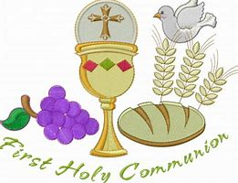
Do This In Memory Of Me

Dear Parent/Guardian,

The Parish are delighted to welcome you to an important information/enrolment meeting for parents and guardians about our ‘Do This In Memory Programme’ at 7:30pm in Holy Rosary Parish Centre on Tuesday 3rd December.

At this meeting we will explain how to programme can help you and your child prepare for the celebration of First Eucharist. The programme is separate from but sits alongside the important work in the schools and the valuable work you do at home to help your child grow in, understand and live the faith.

It would be very helpful if you could complete the registration form that accompanies this letter and bring this with you to the information/enrolment meeting.

The parents/guardians and children who have taken part in the programme in previous years have found that it helped the children and them to gain a much better understanding about the sacrament and brought them together with the whole parish community on a journey towards to the celebration of First Eucharist.

We look forward to seeing you all at the meeting.

Yours sincerely

Fr Brendan Hickland

Enrolment for the Sacrament of First Holy Communion

Name of Child:

School:

Class Teacher:

Would your child like to take part in the Offertory? | Please tick below:  Yes No
Would your child like to take part in the Prayers of the Faithful? | Please tick below:  Yes No
Would you be willing to read the Communion Reflection? | Please tick below:  Yes No
Would you be willing to take part in the ‘Core Group’ meeting? This will be half hour meeting the week. | Please tick below:  Yes No

