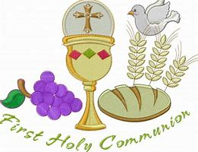
The Do this in Memory programme for Primary 4 children,
preparing for First Holy Communion will begin Sunday 8th December
at 10:30am Mass in Holy Rosary Parish.

