Our Chinese Language classes are back!

It’s wonderful to have our Mandarin lessons up and running again at school.
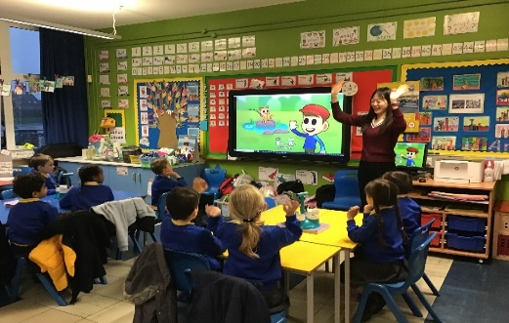
This year our teacher is Miss Cheng. We would like to take this opportunity to welcome Miss Cheng and we hope that she enjoys her time at Holy Rosary teaching all of the boys and girls.
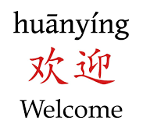

Thank you to all our families who donated items for the South Belfast food hampers.
Christmas is an exciting time of year but for many families it can be a very difficult time of year so thank you for your generosity!
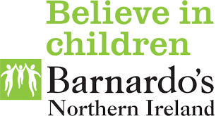
If any of our families need help with food or providing gifts for your children please get in touch as we can help.

Article of the month
Article 13: The right to find out things and share what you think
Sustainable Development Goal of the month (SDG)
Goal 3: Good Health and Well-being
Numeracy News

This half-term we have continued with our monthly ‘Problem Solving Friday’, focusing on a particular strategy within problem solving.
November strategy: trial and error
December strategy: looking for patterns
Literacy News
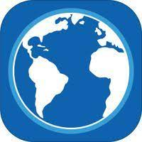

So far this term a total of 315 certificates have been awarded to pupils for their fantastic work on Lexia.
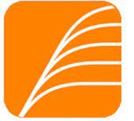
Children have been working just as hard on their AR (Accelerated Reading). So far this term a total of 3727 books and 28,605,421 words have
been read.
P1 Applications

P1 applications for September 2022 will open on Monday 10th January and will close at 12 noon on Friday 28th January. If you need help with this online application please call into see our Parent Worker, Christine.
Our virtual Open Day video can be watched on our website: https://www.holyrosarypsbelfast.com/
Advent
The boys and girls
have been preparing
for Christmeas during
the very special season
of Advent.

We took part in our annual Advent Service this week. Foundation Stage had their service in the school hall. KS1 and KS2 took part in their service via zoom, very kindly led by Fr Hickland who invited some pupils to the church to do readings. Thank you to Fr Hickland and Mrs Blaney for the beautiful services.

Swimming is back!

Our P6 children are loving their swimming lessons
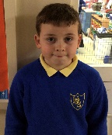
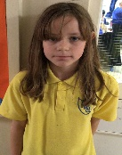
“I like the walk down to the pool.”
“I like the way the swimming coach explains the different techniques.”

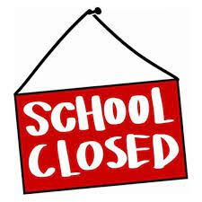
School will be closed for Christmas:
Wed 22nd Dec- Mon 3rd Jan (inclusive)

Festive events:

Tuesday 14th December Advent Service Wednesday 15th December Key Stage Christmas Assembly
Be sure to keep an eye on Showbie where your child’s class performance will be shared. We hope you enjoy it! Friday 17th December Online Panto and a visit from Santa (Thank you to our HSA who provided a selection box for all our children)
Shared Education
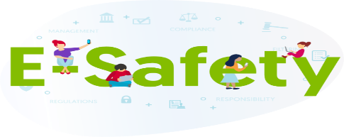
After a year when we were unable to work on joint projects with our partner school due to COVID precautions, we are delighted that our Shared Education partnership with Botanic is back up and running. A P6 and a P7 class will be involved this year. Mr Sinclair’s P6 class have already started their project with their partner class in Botanic PS. The P6 children will be learning about the Vikings and the teachers have planned for innovative ways to ensure that the children in both schools can get to know their partner class and collaborate using Zoom. Mr Mullin’s P7 class will be starting their project on the Victorians in the New Year.

Both at school and at home, children are immersed in the world of ICT. While this comes with obvious advantages, there are also dangers that we need to be aware of. Through our e-Safety lessons in Term
1, we have continued to educate students on these dangers and how to keep themselves safe online.
Connecting Classrooms

N.Ireland Nepal
Creating Compassionate Citizens
Our most recent session was a whole school Art and Wellbeing session. All classes connected virtually with our partner school and an artist on the 8th and 9th November. We created mind jars as part of a mindfulness session. We then learnt about different water landmarks before creating a piece of Art that represented the partnership we have and our two countries coming together.
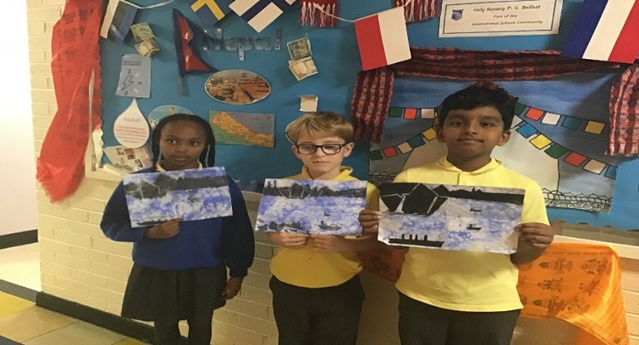
Extended Schools

P4 Literacy and Numeracy classes
Additional support classes for P4 pupils begin on Tuesday 4th January (Literacy) and Thursday 6th January. These classes take place from 3-4pm and are open to all pupils. There are still places available for parents to sign up for these classes on the parent information app.
Parent group
Mindfulness
This term we have been delighted to welcome Graham from MR Sports back in to take mindfulness classes for P3, P6 and P7 children. The sessions have been fantastic ad have helped pupils channel thoughts and energies in positive ways. Term 2 classes will take place for P4, P5 and P7.
SEN provision
The Special Educational Needs Code of Practice has now moved from 5 stages to 3. The new three stages focus on levels of provision for pupils who have SEN: Stage One: Pupils who are recorded as new Stage One will be receiving school delivered special educational provision. Stage Two: Pupils who are recorded as new Stage Two will be receiving school delivered special educational provision plus external provision, e.g. from one of the Education Authority (EA) Pupil Support Services or from a service such as the Health and Social Care Trust. Pupils who are going through the Statutory assessment process will be recorded as Stage Two also. Stage Three: Pupils who are recorded as new Stage Three will have a statement of Special Educational Needs and will be receiving school and EA delivered special educational provision as detailed in their statement. Your child will NOT be affected by the change. The move from five to three stages is simply a clearer and more user-friendly way of recording the level of provision that pupils with SEN need to help them make progress. Literacy service newsletter: https://sway.office.com/7Rfz1XKmO654J8zp?ref=Link The Literacy Service newsletter provides you with lots of ideas of how to help and support your children at home.

Monday 10th Jan- Arts, crafts, tea and coffee
11:00-12:00
This group will be facilitated by our Parent Support workers and is a great opportunity to meet other parents.

