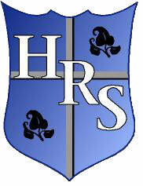

**Holy Rosary Primary School**

**November 2017 - Newsletter No. 5**

**Dates for Your Diary**

* Monday 27th November 3.30pm - HSA Bazaar Planning Meeting in school
* Wednesday 29th November 1.30 pm – Service of Light for P7s in Good Shepherd Church
* Thursday 30th November – **HSA Christmas Bazaar** 6 – 8pm
* Tuesday 5th & Wednesday 6th December 10am - P1 and P2 Christmas Play, 1pm - P3 and P4 Christmas concerts.
* Friday 8th December – School CLOSED
* Saturday 9th December 10 - 12pm – Holy Rosary Nursery School OPEN DAY & P1 classes OPEN DAY
* Tuesday 12th December 9 - 10.30 am – WHOLE SCHOOL OPEN DAY
* Tuesday 12th December 11.15 am – Advent Mass in the Good Shepherd church
* Tuesday 12th December 1.15 pm – P1 & P2 Advent Prayer Service in school
* Wednesday 13th December 1.15 pm – P3 & P4 Advent Prayer Service in school
* Thursday 21st December – Last Day of Term 12.00pm finish

**Parents’ Advice**

Barnardo’s drop-in clinic is available every Friday morning from 8:45 - 9:30 am. This is aimed at Newcomer parents who need support or want to find out more about Barnardo’s family projects.

**Confirmation**

The Service of Light for P7 children is on the Wed 29th November at 1.30pm in the Good Shepherd church. Parents should meet their child in the Church at 1.15pm.

**Christmas Bazaar**

Tickets to visit Santa’s grotto will go on advance sale on Monday 27th November. They will cost £3 including a gift and a photograph and will be available from the school office. Tickets can also be purchased on the night of the bazaar.

**Parent Information**

Please ensure that we have up to date contact details. If you have moved house recently or have changed your landline or mobile number, please let the office know.

**Rights Respecting School - November's Articles of the Month**.

**Article 9:** The right to live with a family who care for you.

**Article 22**: The right to special help and protection if you are a refugee.

Examples of children's work will be posted on our website and twitter!

This month, we are taking part in UNICEF's OutRight campaign, which inspires pupils to stand up for the rights of refugee children. Each class will raise awareness and take action for refugee children separated from their families.

The **NSPCC** visited Holy Rosary Primary School to offer helpful advice about keeping safe and dealing with worries. P5, P6 and P7 then took part in workshops to investigate these ideas further.

We raised a massive **£828.22** for NSPCC during the non-school uniform day. Thank you to everyone for your generous donations!

[](http://www.bing.com/images/search?q=No+Nuts+Sign&id=CF5509924D45840F92A9C7CD33A3EC0968B6CAD2&FORM=IQFRBA)  [](http://www.bing.com/images/search?q=No+Nuts+Sign&id=CF5509924D45840F92A9C7CD33A3EC0968B6CAD2&FORM=IQFRBA)

**Road Safety**

As you are aware we are fortunate to have a dedicated school crossing patrol to ensure that children can cross the road safely in the mornings and after school. Some children are not using the crossing patrol and are crossing the road at very dangerous spots, even between parked cars. If your child is old enough to walk to school themselves can you please talk to them about road safety and the importance of using the crossing patrol every day.

**School of Falconry**

On Monday 13th November, our P3 and P5 children were treated to an information session delivered by the School of Falconry.  John, our expert, brought in five birds of prey (Kestrel, Peregrine Falcon, Barn Owl, Eagle Owl and a Buzzard) and taught the children all about their diet, habitat and characteristics.  We even got to watch them fly and eat.

**P5 Change of Assembly Date**

Miss Devenney’s P5 class assembly will now take place in June 2018 instead of November 2017. Details will be sent out in advance of the assembly.

**Sing Out!**

On Wednesday 15th November, a number of P5 children represented our school at a music night held in Willowfield Church.  The children performed three songs with other primary schools from the local area as part of the Sing Out Project organised by the City of Belfast School of Music.  It was a very entertaining night and we are incredibly proud of the boys and girls who took part.

**Basketball Kits**

The new Basketball kits – funded by the HSA – have arrived and the children just love them.

We’re sure you’ll agree they all look so smart and so professional! A big thank-you to the HSA and to Miss Monahan for organising this.

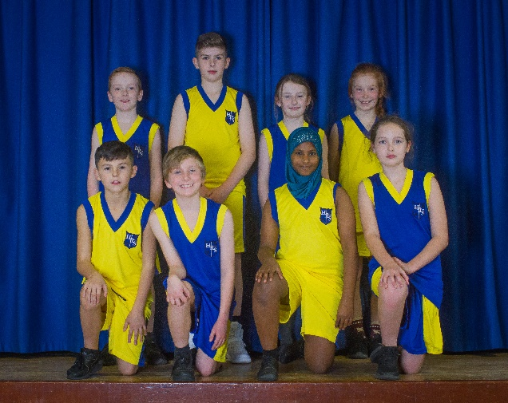

**Reminders**

For all the latest school news follow us on twitter @holyrosaryps

*Remember no nuts or food made in an environment where nuts are present should be*

*brought into school. Many thanks.*

[](http://www.bing.com/images/search?q=No+Nuts+Sign&id=CF5509924D45840F92A9C7CD33A3EC0968B6CAD2&FORM=IQFRBA)  [](http://www.bing.com/images/search?q=No+Nuts+Sign&id=CF5509924D45840F92A9C7CD33A3EC0968B6CAD2&FORM=IQFRBA)