

Holy Rosary Primary School
Principal: Mr Paddy McAllister BEd(Hons), MA(Prim Ed), Ad.Dip.Ed.Man., PQH(NI)

Sunnyside Crescent Tel (028) 90491817
Belfast Fax (028) 90492416
BT7 3DB Email info@holyrosary.belfast.ni.sch.uk
Web www.holyrosarypsbelfast.com

21st March 2018

Dear Parent/Guardian,
RE: Online Reading Systems

Please feel free to avail of the range of online eBooks on the Oxford Owl Website. Our school has invested in an online subscription with two major companies; Oxford and Collins.

On the reverse of this letter please find instructions and login info for accessing the Oxford Owl Website. You and your child can enjoy reading from a huge selection of eBooks and even complete some fun comprehension based activities. HAVE FUN READING TOGETHER!

You can now access these series of books:
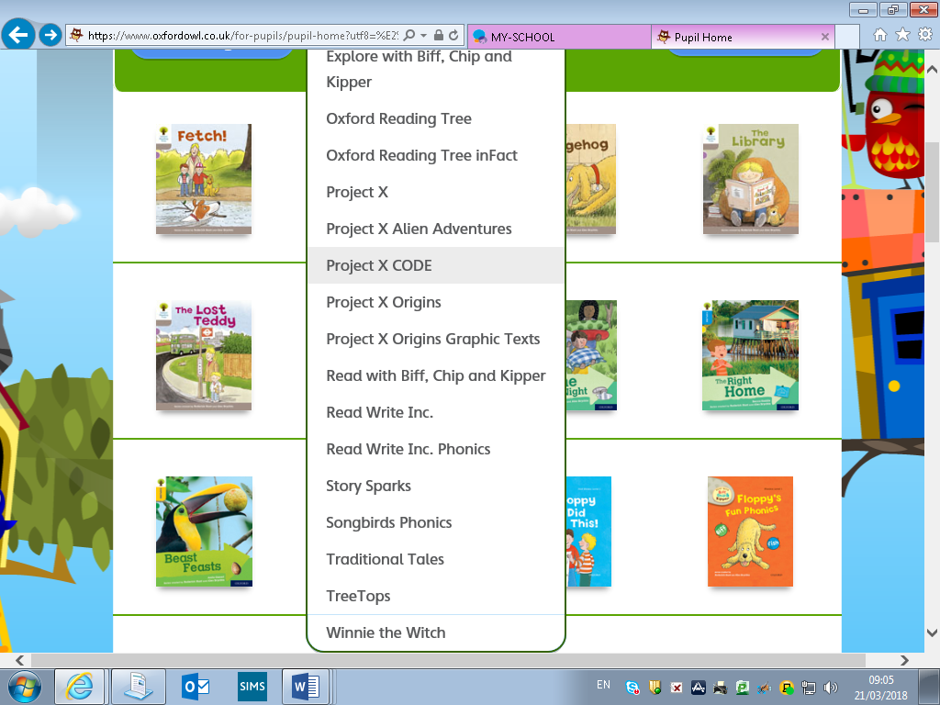

Mr L. McVeigh
Literacy Co-Ordinator

How to access Oxford Owl Class Login:
Step1:
Go to www.oxfordowl.co.uk
Step2:
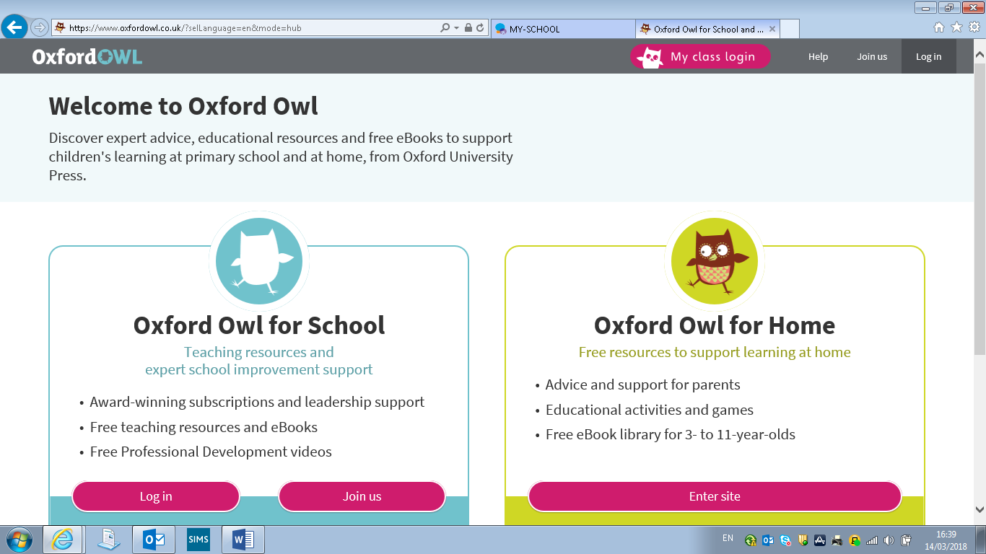
Click on ‘My class login’
Step3:
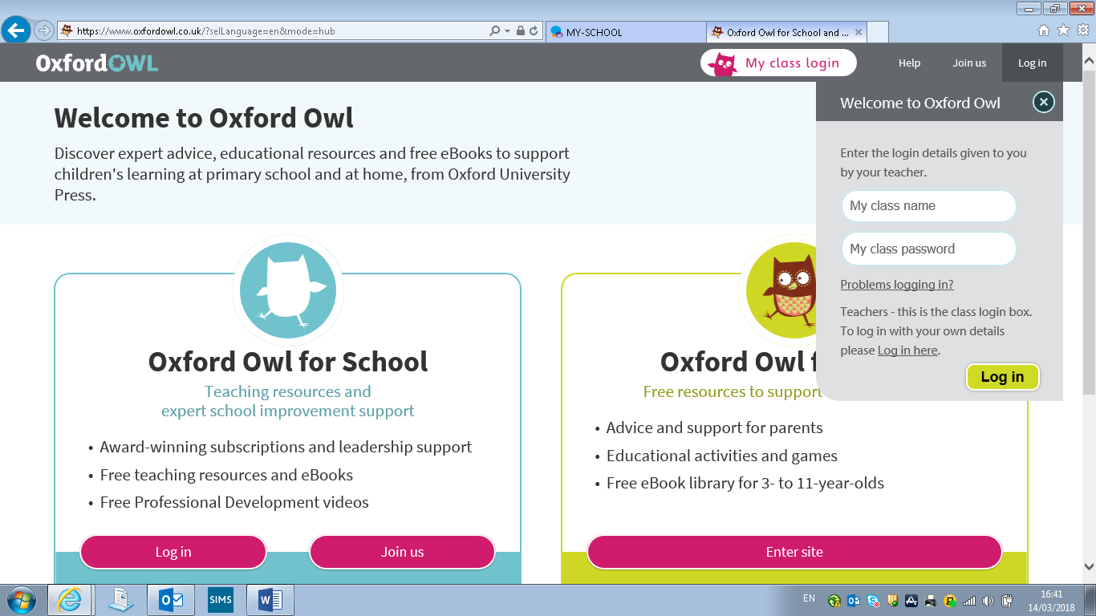
Type in your class name and pass word
Click ‘Log in’
Step4:
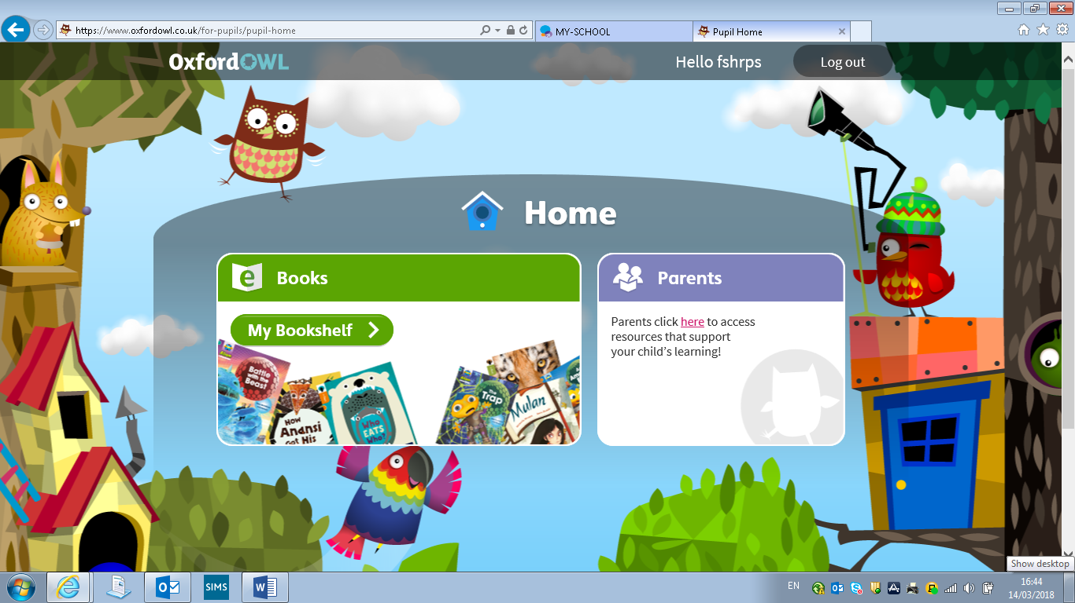
Choose a reading book
Parents can choose resources.

USERNAMES AND PASSWORDS

P1&2 (Foundation Stage)
Username: fshrps
Password: hrpsbelfast1

P3&4 (Key Stage 1)
Username: ks1hrps
Password: hrpsbelfast1

P5 (Key Stage 2)
Username: p5hrps
Password: hrpsbelfast1

P6 (Key Stage 2)
Username: p6hrps
Password: hrpsbelfast1

P7 (Key Stage 2)
Username: p7hrps
Password: hrpsbelfast1

